### [Assignment 3](https://ada.blackboard.com/webapps/assignment/uploadAssignment?content_id=_75341_1&course_id=_2990_1&group_id=&mode=view)

Design a 4-key digital lock that can be opened only when two or more adjacent keys are pressed.

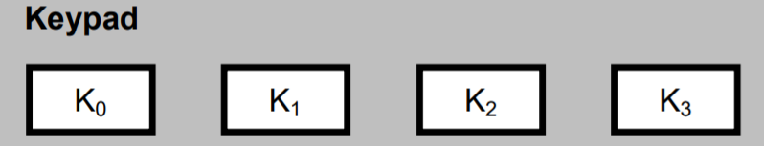

You should deliver a **PDF** file showing state transition tables and diagrams for the given problem, and a **CIRC** file with the corresponding circuit. Submit these two files in a single **ZIP** file.

**Deadline 13.12.2019**